VS Code (Visual Studio Code) is a free code editor used to write, edit, and run code.
For example, in Playwright, you can use VS Code to write your TypeScript automation scripts.
A runtime environment is the environment that allows a program to run.
What is Node.js?
Node.js is a JavaScript runtime environment that allows you to run JavaScript code outside a web browser.
Normally, JavaScript runs in browsers like Chrome. With Node.js, you can run JavaScript directly on your computer and use it to build applications, servers, and automation tools.
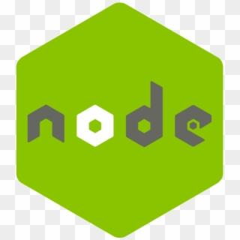
1. Node.js interview questions
1. What is Node.js?
Node.js is a JavaScript runtime environment that allows JavaScript to run outside a web browser.
2. Why do we use Node.js?
We use Node.js to execute JavaScript code, build servers and APIs, and run tools such as Playwright.
3. What is a runtime environment?
A runtime environment provides what is needed to execute a program.
4. What is npm?
npm stands for Node Package Manager. It helps us install and manage packages.
5. Is Node.js a programming language?
No. Node.js is a runtime environment. JavaScript is the programming language.
6. What is the difference between Node.js and JavaScript?
JavaScript is a programming language, while Node.js allows JavaScript to run outside the browser.
7. How do you check the Node.js version?
Run `node -v` in the terminal.
8. How do you run a JavaScript file using Node.js?
Save the file as `app.js` and run `node app.js` in the terminal.
9. What is package.json?
It stores project information, scripts, and package dependencies.
10. Why is Node.js required for Playwright?
Node.js provides the runtime needed to execute Playwright tests written in JavaScript or TypeScript.

2. VS Code interview questions
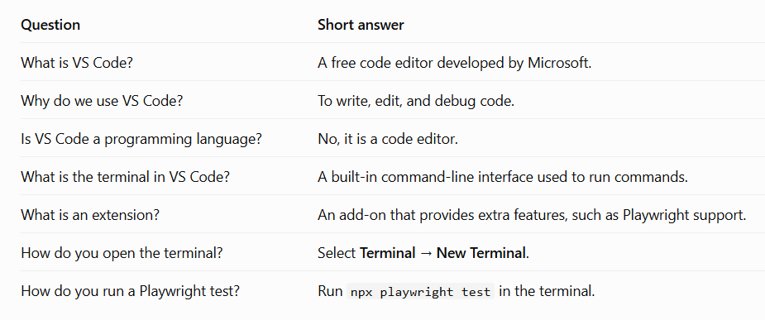
npm interview questions and answers
1. What is npm?
npm stands for Node Package Manager. It helps us install, manage, and update packages in a project.
2. Why do we use npm?
We use npm to install libraries and tools, such as Playwright, in our project.
3. What is a package?
A package is reusable code that we can install and use in our project.
4. What is package.json?
It is a file that stores project information, dependencies, and scripts.
5. What is package-lock.json?
It records the exact dependency versions and related information to help install consistent dependencies.
6. What is node_modules?
It is the folder where npm installs the project's packages and their dependencies.
7. How do you install a package?
Use `npm install package-name`. For example, `npm install lodash`.
8. What is the difference between npm install and npm ci?
`npm install` installs dependencies and may update package-lock.json. `npm ci` installs the locked dependencies for a clean, consistent installation, commonly used in CI.
9. How do you check the npm version?
Run `npm -v` in the terminal.
10. What is a dependency?
A dependency is a package that a project needs to work.
11. What is a devDependency?
A development dependency is a package used during development or testing, such as certain testing tools.
12. How do you install Playwright Test?
Run `npm init playwright@latest` to set up a Playwright project, or `npm install -D @playwright/test` in an existing project.
13. How do you uninstall a package?
Run `npm uninstall package-name`.
14. What is npx?
npx runs a package command without requiring you to install that command globally. It is commonly used to run Playwright tests.
15. How do you run Playwright tests using npm/npx?
Run `npx playwright test` in your project terminal.
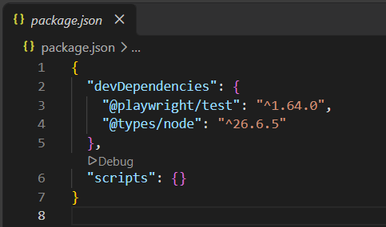
Important interview questions
1. What is package.json?
package.json is a file that stores project information, dependencies, and scripts.
2. What is devDependencies?
devDependencies contains packages required mainly for development and testing, such as Playwright Test.
3. What is @playwright/test?
It is the Playwright testing package used to write, execute, and manage browser automation tests.
4. What is @types/node?
It provides TypeScript type definitions for Node.js APIs, helping TypeScript understand Node.js features.
5. What does the version ^1.64.0 mean?
The caret (^) allows compatible version updates within the 1.x major version range when npm resolves the package version.
6. What is the scripts section?
It lets us define shortcuts for commands, such as running Playwright tests using npm test.
7. What happens when we run npm install?
npm installs the project's dependencies based on package.json and, when available, package-lock.json.
8. What is the difference between package.json and package-lock.json?
package.json declares dependencies and version ranges. package-lock.json records the resolved dependency versions.
9. What is node_modules?
It is the folder where npm stores installed packages and their dependencies.
10. How can you run Playwright tests using an npm script?
Add the script "test": "playwright test" and run `npm test`.
11. Why is Playwright under devDependencies?
Because it is generally used to develop and run automated tests rather than to serve the production application.
12. What does an empty scripts object mean?
No custom npm scripts have been defined in that section yet. You can still run commands such as `npx playwright test`.
1. Basic interview questions
Q1. What is the node_modules folder in Playwright?
Answer: The node_modules folder contains the packages and libraries installed in a Node.js project. Playwright uses these packages to run automated tests.
Q2. Why is the node_modules folder created?
Answer: It is created when we install project dependencies using npm.
For example:
npm install
This command reads package.json and installs the required packages into node_modules.
Q3. What is npm?
Answer: npm stands for Node Package Manager. It helps us install, update, and manage packages required for our project.
Q4. What is the difference between node_modules and package.json?
node_modules | package.json
Contains installed packages and their files. | Contains project details and dependency declarations.
Can be very large. | Usually a small JSON file.
Generated or updated by npm. | Stores scripts, project metadata, and dependency information.
Q5. What is the difference between package.json and package-lock.json?
Answer:
- package.json specifies dependencies and version ranges, along with scripts and other project information.
- package-lock.json records the exact dependency versions and dependency tree npm resolved, helping reproduce installations.
2. Playwright-specific interview questions
Q6. Which command installs Playwright Test?
npm install -D @playwright/test
This installs Playwright Test as a development dependency.
Q7. What is the purpose of @playwright/test inside node_modules?
Answer: It provides the Playwright Test framework, including test, expect, fixtures such as page, and test-running functionality.
Q8. What happens if we delete the node_modules folder?
Answer: The installed packages are removed from the project folder, so tests may not run until the dependencies are installed again.
To restore them, run:
npm install
Q9. Do we need to install Playwright again if we delete node_modules?
Answer: Usually, no separate installation command is needed if package.json and package-lock.json are present and contain the required dependencies. Running npm install restores them.
Q10. Should we upload the node_modules folder to GitHub?
Answer: Usually, no. We add node_modules to .gitignore because it can contain many files. Instead, we commit package.json and package-lock.json so other developers can install the dependencies.
Q11. What is the difference between npm install and npm install @playwright/test?
- npm install installs the dependencies declared in the project.
- npm install @playwright/test installs the specified Playwright Test package and adds it as a regular dependency unless a different option is used.
- npm install -D @playwright/test adds it as a development dependency.
Q12. Where are third-party packages installed?
Answer: Typically, npm installs local project dependencies in the project's node_modules folder. Some packages can also be installed globally.
3. Scenario-based interview questions
Q13. You received a Playwright project from another tester, but it does not contain node_modules. What will you do?
Answer:
- Open the project folder in VS Code.
- Open the terminal in that folder.
- Run:
npm install
4. Run the tests:
npx playwright test
Q14. You get the error Cannot find module '@playwright/test'. What could be the reason?
Answer: The dependency may not be installed, the terminal may be in the wrong project directory, or the installation may be incomplete.
Try:
npm install
If the package is missing from package.json, install it with:
npm install -D @playwright/test
Q15. Can we manually create the node_modules folder?
Answer: We should not create it manually. npm creates and manages it when we install packages.
Q16. What is the difference between local and global package installation?
Answer:
- Local: Installed for a particular project, usually inside its node_modules folder.
- Global: Installed for use from multiple projects or the command line, depending on the package.
Q17. Why can the node_modules folder contain nested node_modules folders?
Answer: Different packages may require different versions of the same dependency. npm can place dependencies in nested folders when necessary.
Q18. What does npx playwright test do?
Answer: It runs Playwright's test runner, normally using the locally installed Playwright Test package.
4. Practical commands to remember
Command | Purpose
npm init -y | Creates a basic package.json.
npm install -D @playwright/test | Installs Playwright Test as a development dependency.
npm install | Installs project dependencies.
npm list @playwright/test | Shows the installed Playwright Test version.
npx playwright test | Runs Playwright tests.
npx playwright --version | Displays the Playwright CLI version.
5. Quick mock interview
Try answering these five questions without looking at the answers.
1. What is the purpose of the node_modules folder?
It stores the installed packages and libraries used by the project.
Hide answer
2. Why do we use package-lock.json?
It records the resolved dependency versions and dependency tree so installations can be reproduced more consistently.
Hide answer
3. What command restores missing dependencies?
Run npm install from the project directory, provided the required dependencies are declared in package.json.
Hide answer
4. Should node_modules be committed to Git?
Usually not. Add it to .gitignore and commit package.json and package-lock.json.
Hide answer
5. What is @playwright/test?
It is the Playwright testing package that provides test(), expect(), fixtures, and the test runner.
Hide answer

1. Basic interview questions
Q1. What is playwright.config.ts?
Answer: playwright.config.ts is the configuration file of a Playwright project. It allows us to define settings that control how our tests execute.
For example, we can configure:
- Browser
- Base URL
- Test timeout
- Headless or headed mode
- Screenshots and videos
- Retries
- Parallel execution
- Reports
Q2. Why do we use playwright.config.ts?
Answer: We use it to manage common test settings in one place instead of repeating the same settings in every test file.
Q3. What is the default configuration file name?
Answer: playwright.config.ts for a TypeScript configuration. Playwright also supports JavaScript configuration files.
Q4. What is the purpose of defineConfig()?
Answer: defineConfig() is a helper function imported from @playwright/test. It helps us define the configuration and provides TypeScript support and editor suggestions.
import { defineConfig } from '@playwright/test';

export default defineConfig({
testDir: './tests',
});
Q5. What is export default in the configuration file?
Answer: It exports the configuration object as the default export, allowing Playwright to load the settings from this file.
2. Important configuration options
Consider this example:
import { defineConfig, devices } from '@playwright/test';

export default defineConfig({
testDir: './tests',
timeout: 30000,
retries: 1,
workers: 2,
reporter: 'html',

use: {
baseURL: 'https://example.com',
headless: true,
screenshot: 'only-on-failure',
trace: 'on-first-retry',
},

projects: [
{
name: 'chromium',
use: { ...devices['Desktop Chrome'] },
},
],
});
Q6. What is testDir?
Answer: It specifies the folder where Playwright looks for test files.
testDir: './tests'
Here, Playwright looks in the tests folder.
Q7. What is timeout?
Answer: It defines the maximum time allowed for an individual test to complete before it times out. The default test timeout is generally 30 seconds.
timeout: 60000
This sets the test timeout to 60 seconds.
Q8. What is expect timeout?
Answer: It specifies how long an assertion such as expect(locator).toBeVisible() waits for the expected condition. Its default is generally 5 seconds.
expect: {
timeout: 10000,
}
This sets the assertion timeout to 10 seconds.
Q9. What is retries?
Answer: It specifies how many times Playwright retries a failed test.
retries: 2
If a test fails, Playwright can retry it up to two times.
Q10. What is workers?
Answer: Workers control how many worker processes Playwright uses to run tests.
workers: 4
Playwright can use up to four workers, subject to available tests and other constraints.
Q11. What is fullyParallel?
Answer: It controls whether tests within files can run in parallel, rather than restricting parallelism mainly to separate test files.
fullyParallel: true
Q12. What is baseURL?
Answer: It defines the common base URL for the application under test.
use: {
baseURL: 'https://example.com',
}
Then we can write:
await page.goto('/login');
Playwright combines the relative path with the configured base URL.
Q13. What is headless mode?
Answer: In headless mode, the browser runs without displaying its graphical user interface.
use: {
headless: true,
}
To run with a visible browser window:
use: {
headless: false,
}
Q14. What is screenshot?
Answer: It controls when Playwright captures screenshots during test execution.
screenshot: 'only-on-failure'
Common options include:
- 'off'
- 'on'
- 'only-on-failure'
Q15. What is video?
Answer: It controls when Playwright records test execution as a video.
video: 'retain-on-failure'
This keeps the video for failed tests. Other options include 'off', 'on', and 'on-first-retry'.
Q16. What is trace?
Answer: Trace recording captures information useful for debugging, such as actions, snapshots, and network activity.
trace: 'on-first-retry'
This records a trace when a test is retried for the first time.
3. Browser and project configuration questions
Q17. What is the use option?
Answer: The use option defines settings for the browser and browser context used by tests, such as baseURL, headless, viewport, and screenshot.
Q18. What is the projects option?
Answer: It allows us to run tests with different configurations, such as different browsers, devices, or environments.
projects: [
{
name: 'chromium',
use: { ...devices['Desktop Chrome'] },
},
{
name: 'firefox',
use: { ...devices['Desktop Firefox'] },
},
]
Q19. Can we run tests in multiple browsers using one configuration file?
Answer: Yes. We can define Chromium, Firefox, and WebKit as separate projects in the same configuration file.
Q20. What is devices in Playwright?
Answer: devices provides predefined device configurations, including settings such as viewport size, user agent, and device scale factor.
Q21. What is the difference between Chromium, Chrome, and WebKit?
Answer: Chromium is an open-source browser project, Chrome is Google's browser built on Chromium, and WebKit is a browser engine used by Safari.
Q22. What is reporter?
Answer: It defines how test results are displayed or saved.
reporter: 'html'
Other common reporter choices include 'list', 'line', 'dot', and 'json'.
4. Scenario-based interview questions
Q23. You want to run your tests in a visible browser. What will you change?
Answer:
use: {
headless: false,
}
Q24. Your tests are taking too long and failing because of a timeout. What will you do?
Answer: First, investigate why the test is slow. If a longer timeout is genuinely required, increase the test timeout:
timeout: 60000
This allows up to 60 seconds per test.
Q25. You want screenshots only when a test fails. How will you configure it?
Answer:
use: {
screenshot: 'only-on-failure',
}
Q26. You want to rerun failed tests automatically. Which option will you use?
Answer:
retries: 2
Q27. You want to run tests against your application's UAT environment. How will you configure it?
Answer:
use: {
baseURL: 'https://your-uat-application-url.com',
}
Then use relative URLs in your tests:
await page.goto('/login');
Q28. Your tests pass locally but fail in CI. Which configuration settings might you investigate?
Answer: Check the browser installation, environment variables, baseURL, timeouts, worker count, retries, and trace or screenshot settings. Also investigate differences in the test data and environment.
Q29. What happens if we have different use settings at the global and project levels?
Answer: Project-level settings can override global settings for that project. Test-level settings can also override applicable project settings.
Q30. How can you specify a different configuration file when running tests?
Answer: Use the -c or --config option.
npx playwright test -c playwright.uat.config.ts
This tells Playwright to use the specified configuration file.
5. Difference-based interview questions
Question | Simple answer
timeout vs expect.timeout | Maximum duration for a test vs maximum waiting time for an assertion.
retries vs workers | Number of retries for failed tests vs number of worker processes.
baseURL vs page.goto() | Common starting URL vs the navigation method used to open a URL.
headless: true vs false | Browser runs without a visible window vs with a visible window.
screenshot vs trace | Image of the page vs a richer record of test execution for debugging.
testDir vs testMatch | Test directory vs patterns used to identify test files.
Global use vs project use | Shared settings vs settings for a particular project.
6. Quick interview practice
Try answering these questions yourself. Select Show answer to check your understanding.
1. Which option defines the folder containing your tests?
testDir
baseURL
reporter
2. Which option configures the base URL of your application?
workers
baseURL
retries
3. Which option controls the number of retries for failed tests?
timeout
projects
retries
4. Which option enables HTML test reports?
reporter: 'html'
headless: true
fullyParallel: true
5. Which option captures a trace on the first retry?
trace: 'off'
trace: 'on-first-retry'
screenshot: 'on'
What are dependencies in Playwright?
“Dependencies are external packages or libraries required by a project. In Playwright, we install packages such as @playwright/test to write and execute automated tests. npm manages these packages, package.json declares them, and node_modules stores their installed files.”
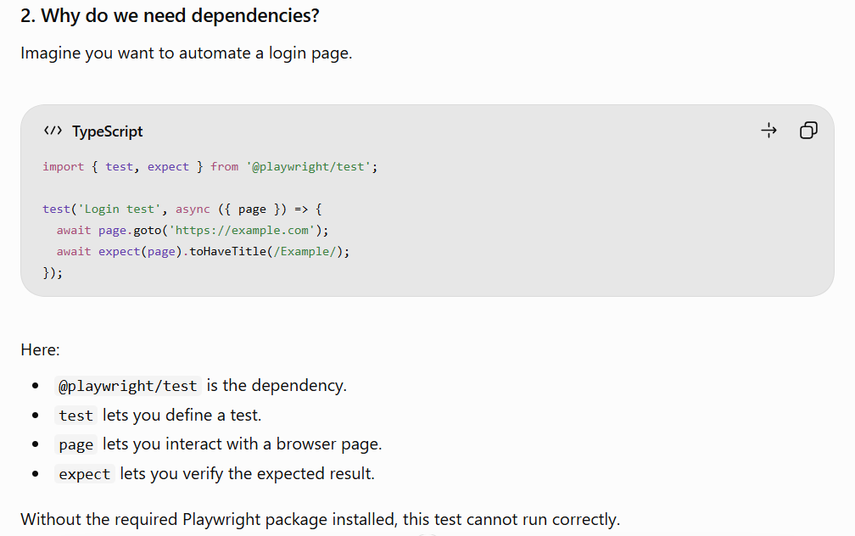
.gitignore is a file that tells Git which files and folders it should ignore when tracking changes in your project.
- Why do we use .gitignore in Playwright?
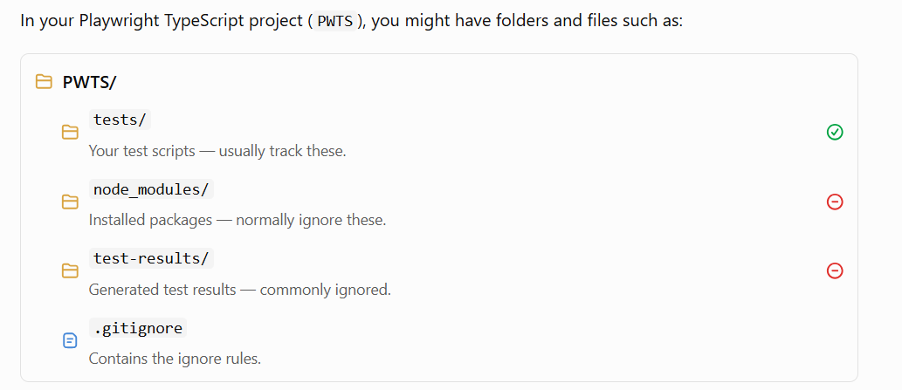
2. What does a .gitignore file contain?
For example, your .gitignore file could contain:
node_modules/
test-results/
playwright-report/
Meaning:
- node_modules/ — Git ignores the installed dependencies folder.
- test-results/ — Git ignores generated test results.
- playwright-report/ — Git ignores the generated HTML report folder.
These are common examples; you can customize the rules for your project.
3. What happens when we use .gitignore?
Suppose you run:
git add .
Git stages new and modified files, except files that match applicable ignore rules and are not already tracked.
For example:
File/folder | Git behavior
LoginPage.spec.ts | Normally tracked
playwright.config.ts | Normally tracked
package.json | Normally tracked
node_modules/ | Ignored if listed in .gitignore
playwright-report/ | Ignored if listed in .gitignore
Important: .gitignore does not delete files from your computer. It only tells Git to ignore matching untracked files. Files already tracked by Git remain tracked until you remove them from tracking.
4. How do you create .gitignore in VS Code?
- Open your PWTS project folder.
- Right-click the project folder in the Explorer panel.
- Select New File.
- Name the file .gitignore.
- Add the ignore rules you need.
- Save the file.
5. Common interview questions
Q1. What is .gitignore?
It is a file containing patterns that tell Git which untracked files and folders to ignore.
Q2. Why do we ignore node_modules?
It can contain thousands of dependency files. We normally share package.json and package-lock.json so other developers can install the same dependencies instead.
Q3. Does .gitignore delete files?
No. It only affects Git's handling of matching untracked files.
Q4. Will .gitignore ignore a file that Git is already tracking?
No. You must remove it from Git's index if you want Git to stop tracking it, for example:
git rm --cached filename
Q5. What is the difference between .gitignore and .git?
- .gitignore contains rules for files Git should ignore.
- .git is the repository's internal directory, which stores Git metadata and version-control information.
Remember for your interview: .gitignore helps keep your repository clean by excluding generated files, installed dependencies, and other files that should not be committed.

